First Semester 2026 Admn
MCA CP 106 Database Technology Lab (Mysql & Mongodb)
Module 3
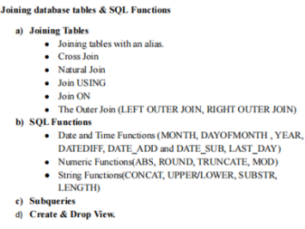

10. Perform Join operations
  - Create the tables and insert the following data into the tables.

Salesman
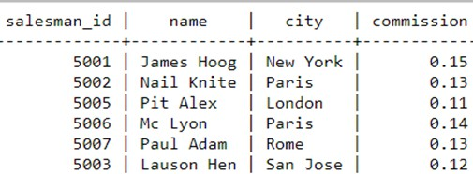

Customer

customer_id cust_name city grade salesman_id
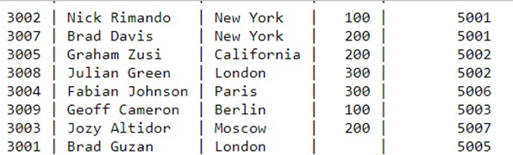

Orders
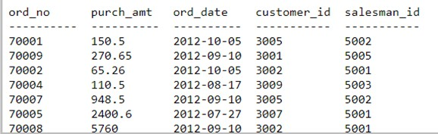

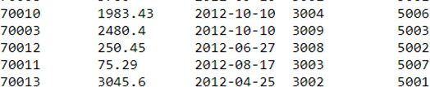

- Find the names of salesmen and customer who belongs to the same city.
- Display the purchase details of customers( Customer name, orderno, amount and city) in which the order amount between 100 and 1000.
- Find the salesman appear for all customers and vice versa. (Hint: Cross join)
- Display the details to know which salesman are working for which customer.(Hint : Inner Join)
- Find out the customers who holds a grade less than 200 and works either through a salesman or by own.Also display the customer names in sorted order.(Hint : Left Join)
- Find the customer name, order number, order date, and order amount in descending order according to the order date to find that either any of the existing customers have placed no order or placed one or more orders.(Hint : Left Outer Join)

11. FUNCTIONS
A. Numeric Functions
1. Abs(-5)
2. Truncate(1.83579,3)
3. Mod(31,3)
4.Round(5)
B. STRING FUNCTIONS
1.Display the customer names in deposit table in lower case
2. Display customer names in deposit table in uppercase
3. Display the customer name and length of each name.
4.Find the length of a string in bits.
5. Concatenate customer name and branch name from the table deposit C. Date Functions
1. curtime(), curdate()
2. year()
3. month(), monthname()
4.dayofyear(), dayofmonth(), dayofweek()
5. hour(), minute(), second()
6.to_days()
7. from_days()
8. date_add(), date_sub()
12. SUB-QUERIES
1.Insert into deposit a new record (107,Sandeep,Ajne,2000,12032011).Display the customers' names whose branch is same as that of the branch of Sndeep.
2.Give the number of customers who are depositors as well as borrowers. 3.Delete the record from loans who have a deposit.
13. VIEWS IN DBMS
1. Create a view for the table deposit with fields accno, cust name and branch name
2. Create a view that gives information about customer name, deposit amount and living city
3. Create a view to display the borrow details having loan no 206
4. Drop a view

